1. **Agenda:**
   1. orphanRemoval attribute.
2. It helps us to avoid constrain violation exception.
3. 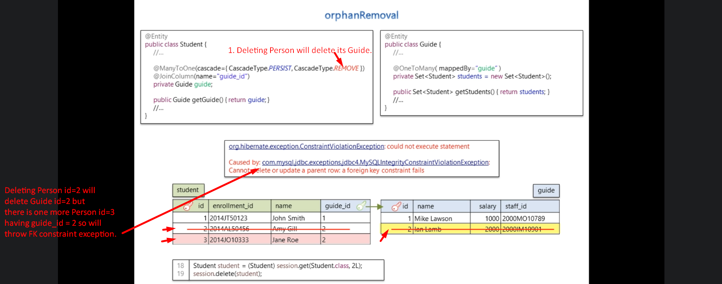
4. 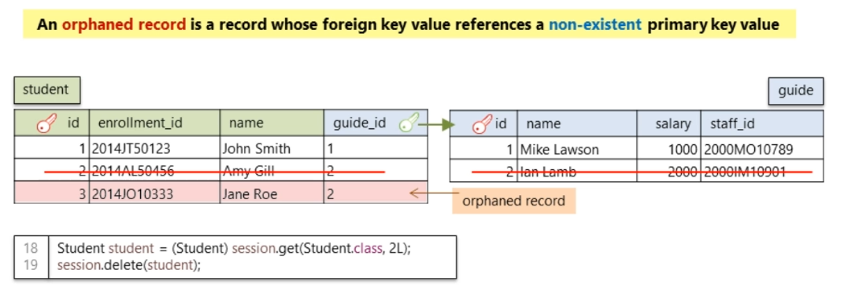
5. 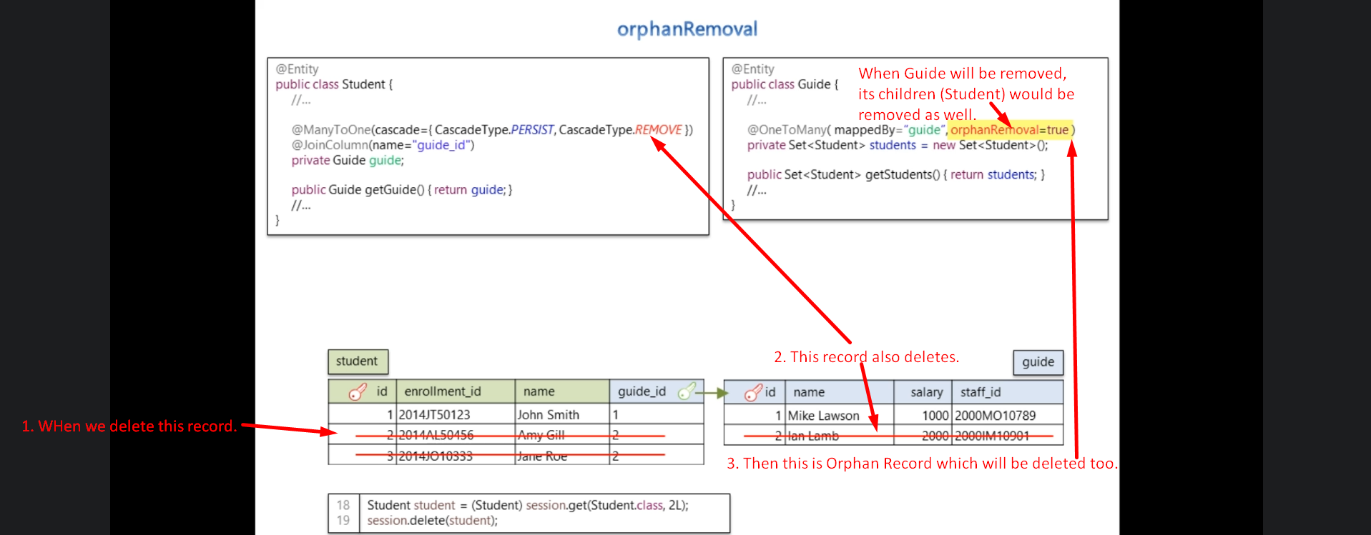
6. 